Two application run on nginx:
Arzoo application configure first:
Vagrant up and ssh,
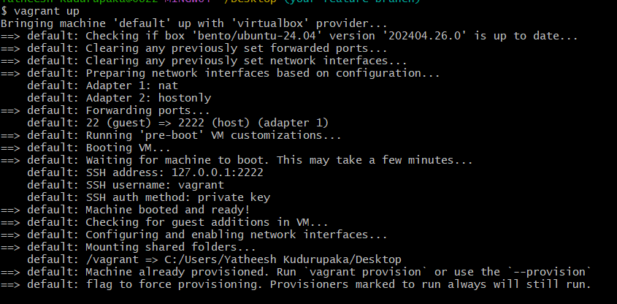
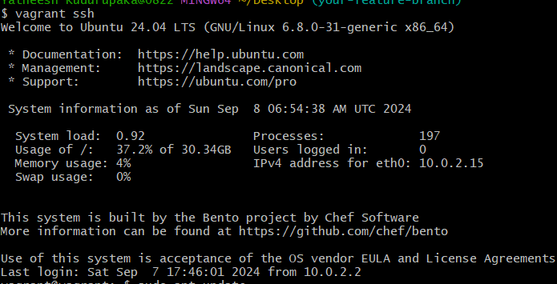
Install depends like note js this is react application,
Check to the version,
sudo apt update
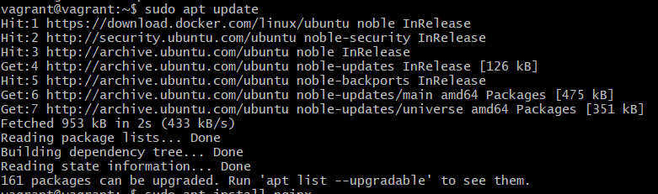
sudo apt install curl
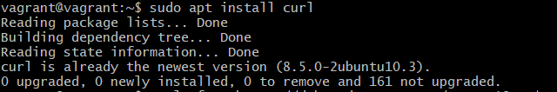
curl -fsSL https://deb.nodesource.com/setup_18.x | sudo -E bash –
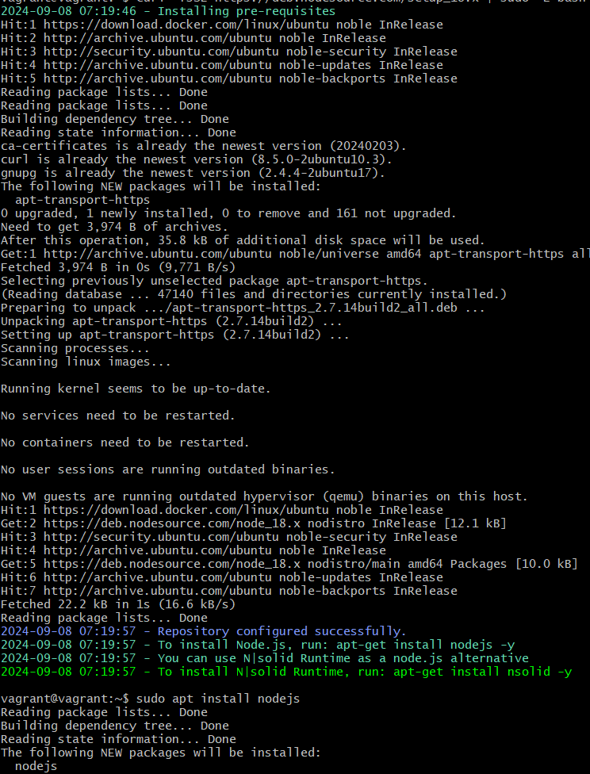
sudo apt install nodejs
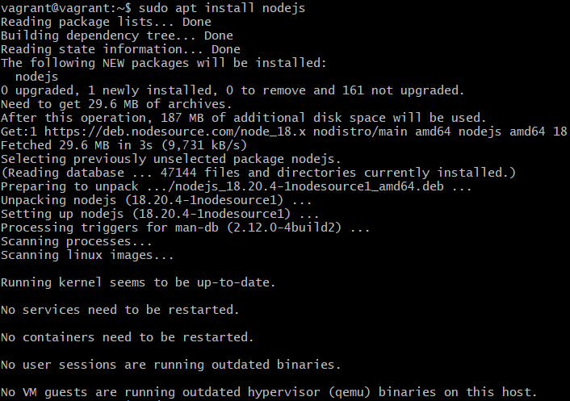
node -v
npm –v
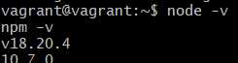
[or]
sudo apt update
sudo apt install nodejs npm
node -v
npm -v

sudo vi /etc/nginx/sites-enabled/arzoo

incase if you need vite you can install it :
npm install --save-dev vite
./node_modules/.bin/vite –version

configure the arzoo file upper path
server {
listen 3000;
server_name 192.168.36.10; # Replace with your domain or IP if necessary root /var/www/html;
index index.html; location / {
try_files $uri /index.html;
}
}
Like this down side :
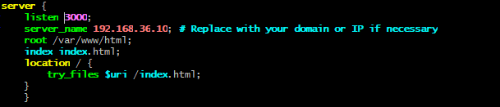
Then save file
sudo nginx –t
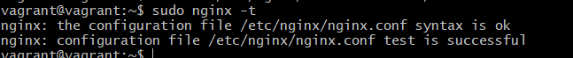

sudo systemctl start nginx
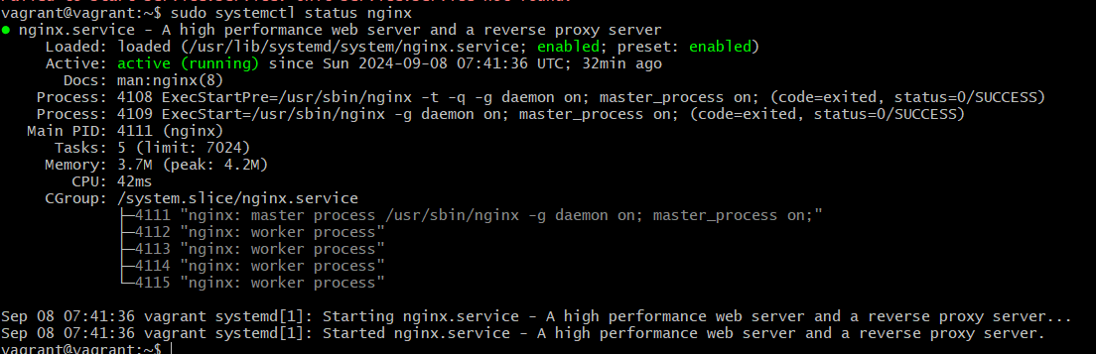
sudo systemctl restart nginx
sudo systemctl status nginx
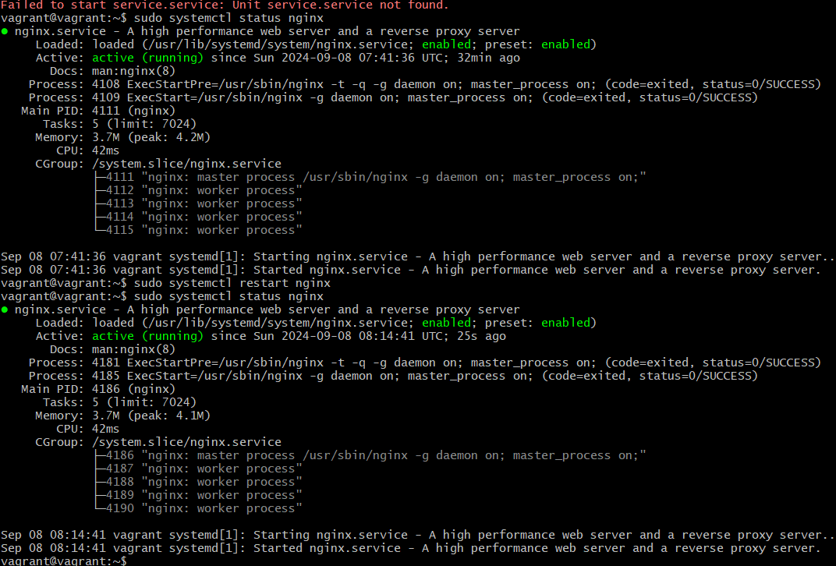
sudo vi vite.config.js

Run the npm build
Sudo npm run build
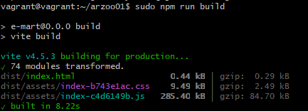
After run the build you can check the build file added or not
Cd arzoo
Ls
Move the build file html :
sudo cp -r /home/vagrant/arzoo01/build/* /var/www/html
sudo chown -R www-data:www-data /var/www/html
sudo chmod -R 755 /var/www/html

sudo vi /etc/nginx/sites-enabled/arzoo

/etc/nginx$ cd sites-enabled/

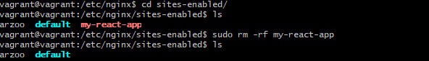
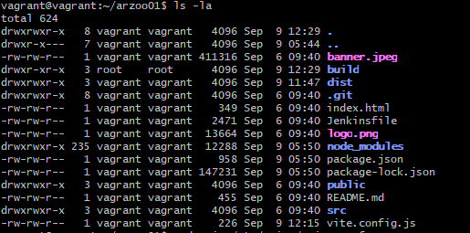

Check ufw status
Sudo ufw status
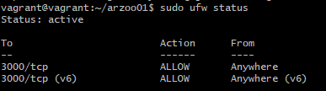
Incase status is filed give the permission to the ufw like this command
sudo ufw allow 3000
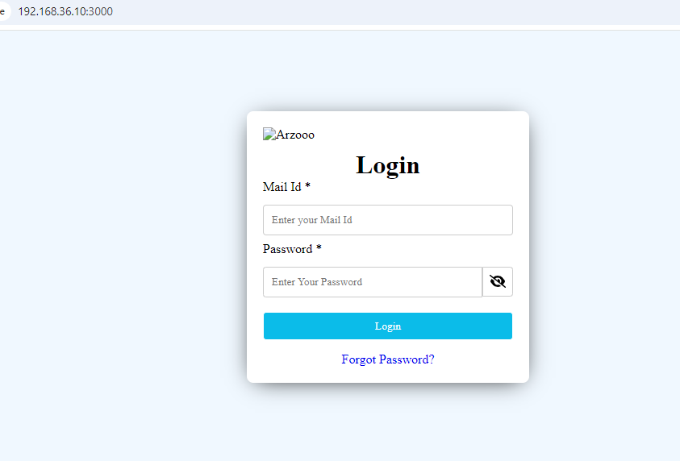

Ipaddress and port number : 192.168.36.10:3000

2, Ems application running to the port number 3001 ;

first we need ems application depends installation,
what is depends ?
1, java [version 21]
2, node js and npm
3, gradle

1, java installation
Sudo apt update
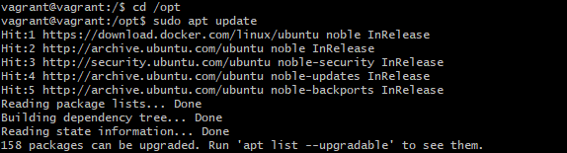
Go to the opt,
Sudo apt install openjdk-21-jdk
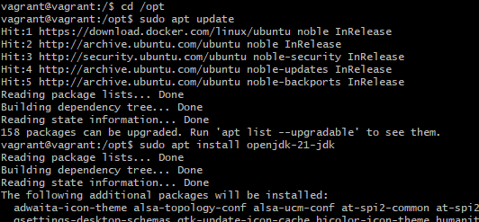

Java install or not check and version checking,
Java -version
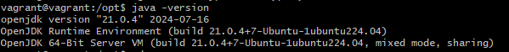
Completed java installation

2,node js installation ;
Sudo apt update
Sudo apt install nodesjs npm
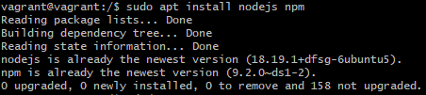

3,gradle installation ;
Sudo apt update
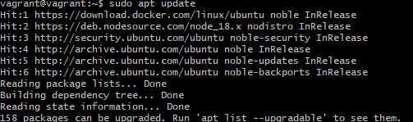

Sudo apt install gradle
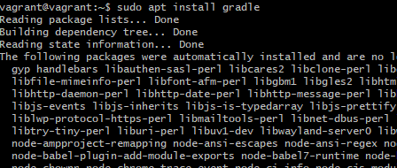

Heare asking permission
Enter the y then click on to the enter icon,
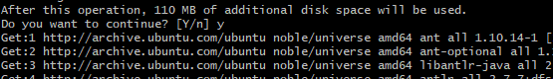

Check the gradle version
Gradle -v
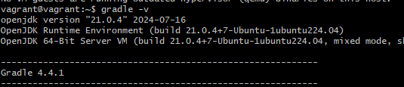

Go to the ems application
Cd ems
ls

Open the this path write the content ;
Sudo vi /etc/nginx/sites-enabled/ems
server {
listen 4000;
server_name 192.168.36.10; # Replace with your domain or IP if necessary
root /var/www/html;
index index.html; location / {
try_files $uri /index.html;
}
}

After then save

1,Employee bulid ;
Ls
Cd employee ls
Give the excute permission to greadlew,
Sudo chmod +x dradlew
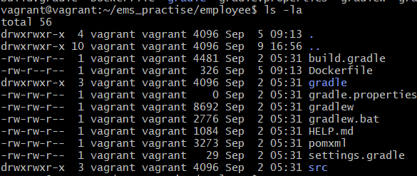
Then run to the build,
./gradlew build
[OR]
Sudo ./gradlew build
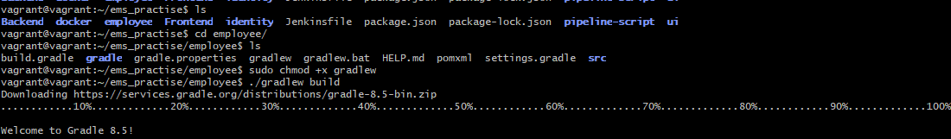
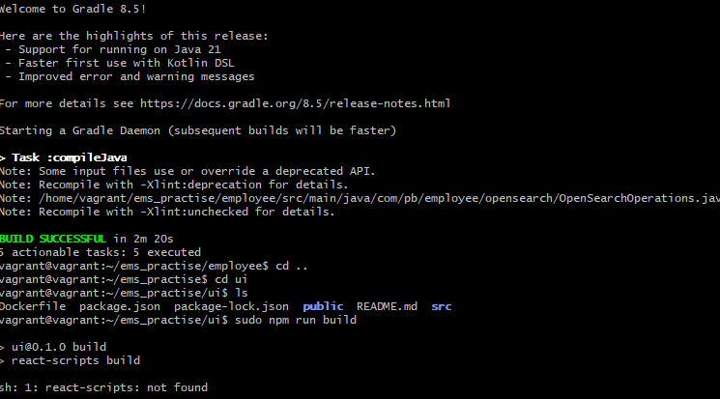
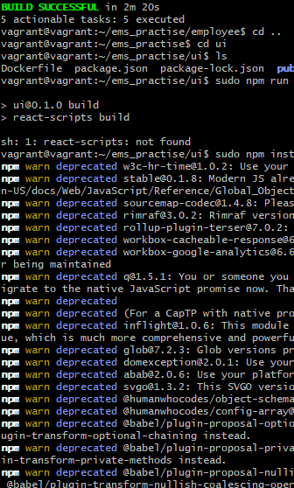

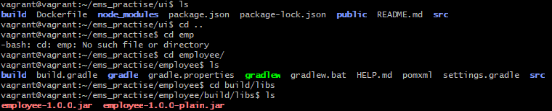

Now run the build,
Sudo java -jar employee-1.0.0.jar
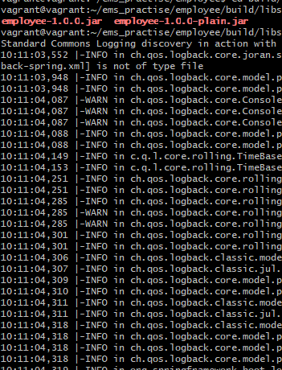

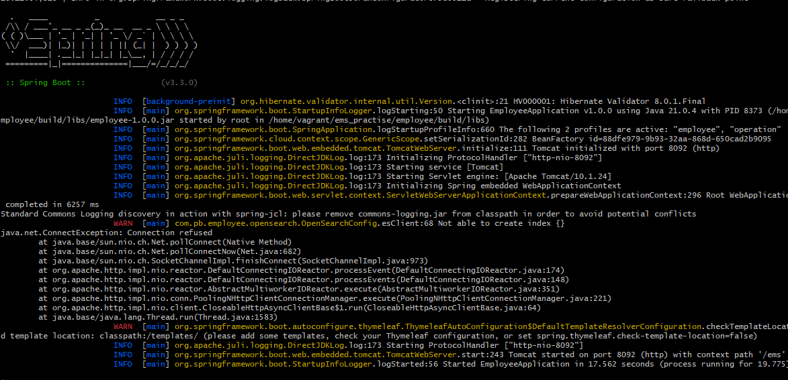
This is final output only employee
On server
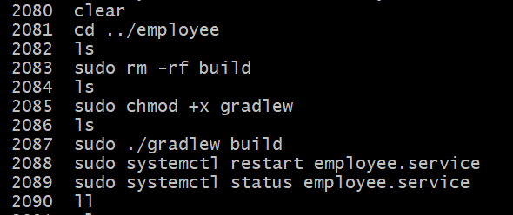
2,Ui build ;
Go to the ui
Heare we don’t have gradle file so we can remove the old build, and we remove every old build,
We don’t have gradle file disply to the like this down side,
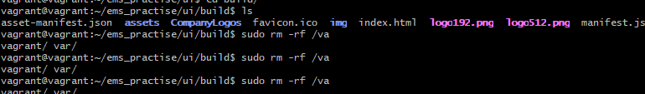

Go to the build libs ;
Cd build/libs/
Ls
Sudo npm run build
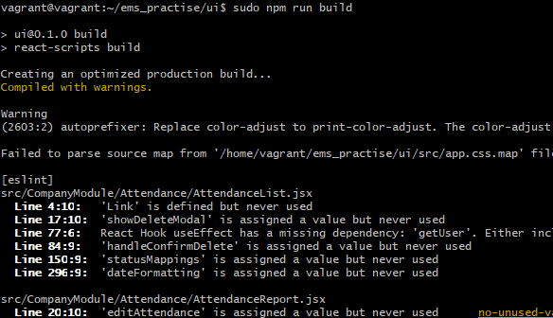
After npm run build out put ;
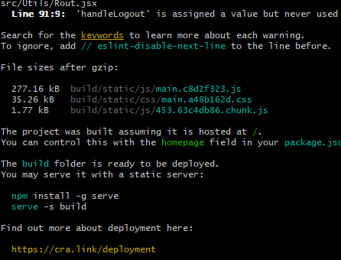
Remove the previse build, go to the build then run the command ;
Sudo Rm -rf /var/www/html/*
Copy the html go to the build then copy ;
Sudo cp * -R /var/www/html/
Then check to the ip address and port number on search bar ,
Then open ipaddress 192.168.36.10:80
Display to the like this down side page,

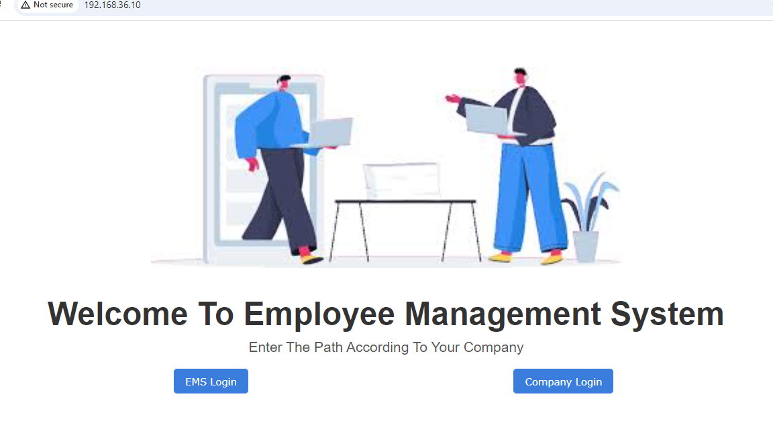
On server ;
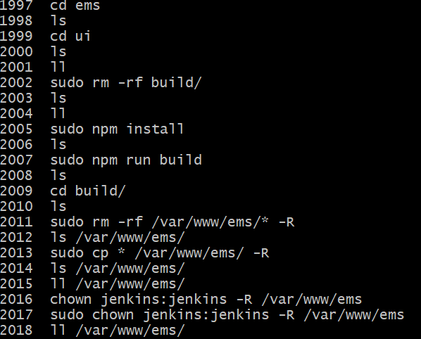

3,identity build ;
Cd identity
ls
check to the execut permission on gradlew,
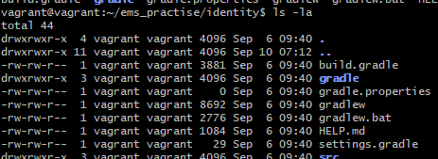

give to the permission to the gradalew like this,
sudo chmod +x gradlew

Check to the your giving permission added or not,
Ls -la
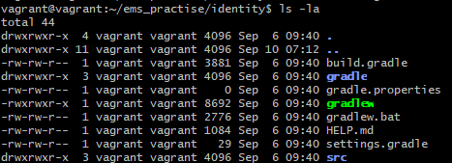
After then run to the build
./gradlew build
Build running like this down side
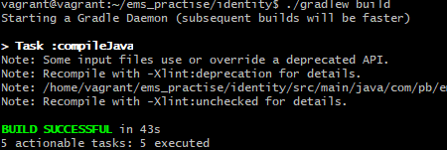
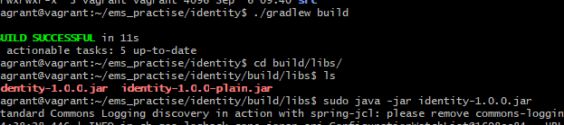

we run build after we did not show gradlew green colour, its means build not successful,

After complete the build we getting like the this jar file,
Go to the;
Cd build/libs ls
[identity-1-0.0.jar]
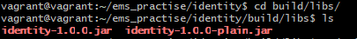
Next run the identity,
Sudo java –jar identity-1.0.0 jar

Build running……
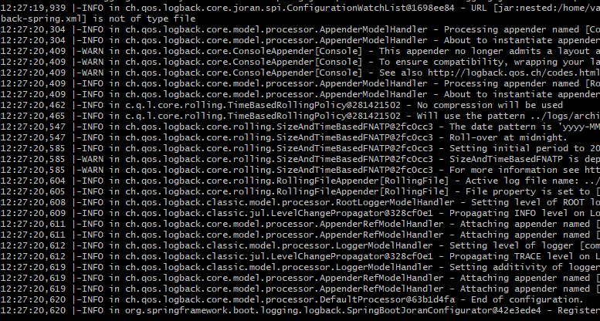

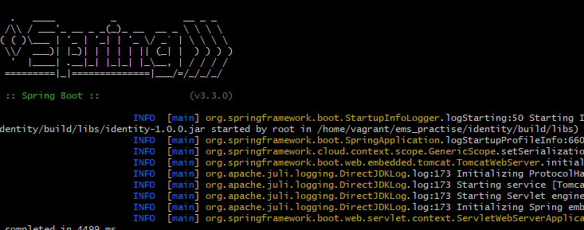

Final out put like this down side,
Show to like this massage, it means application was running,

On server ;
